Blandford Hill Wind Farm
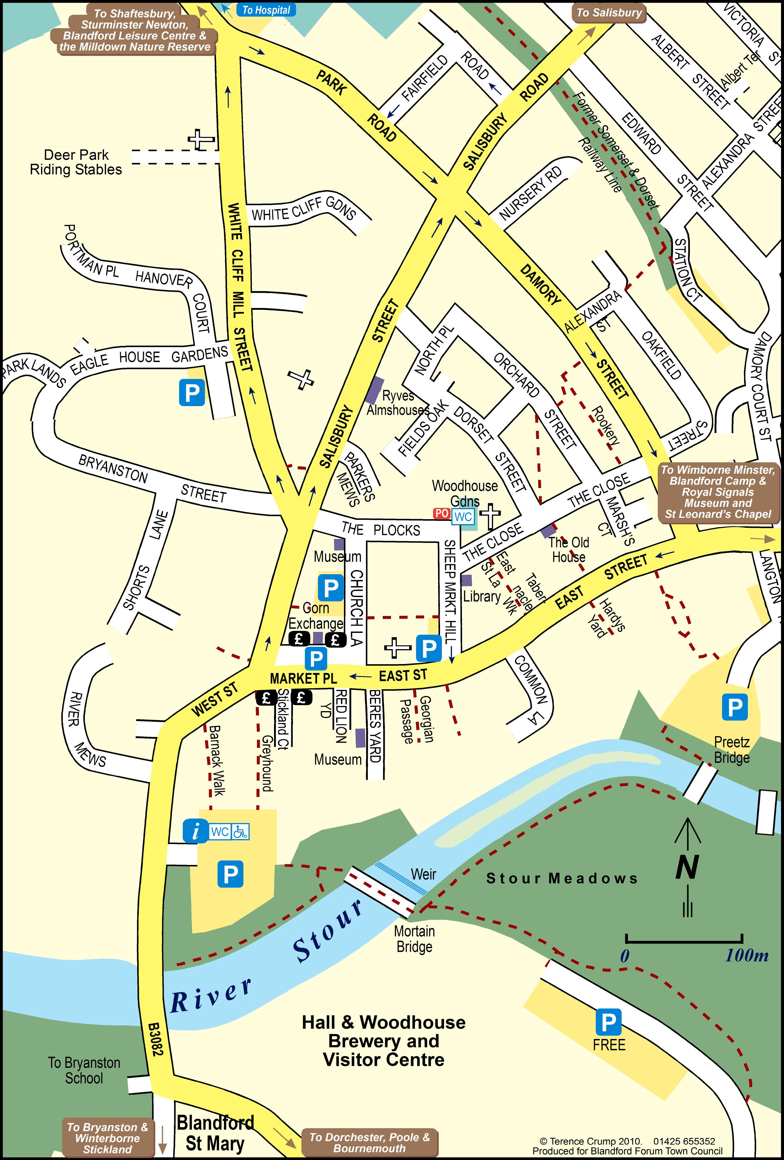
Planning Application now in
A meeting for people in support
Wednesday, 9th July , 7pm
Woodhouse Garden Pavilion
PO
Next to Post Office
The Plocks, Blandford Forum
DT11 7DN

Members of West Dorset Pro Wind Group will be
coming along to share experience.

Interested, but can’t attend?
Email- westdorsetprowind@outlook.com

Invite others along too!

